<TITLE OF YOUR SYSTEM>

<Chae-Eun Jeong, Dankook University, chaeun.jjj@gmail.com>

# Purpose of tokens

# I designed a cryptoeconomic system which is for the women-only car sharing platform. Only women can join the platform and if there is a car owner whose destination is similar with user, then user can reserve to sharing the car. Between the owner of the car and users, they could use smart contract to promise trustworthy. Users can evaluate about all of the car and then the owner can get incentives proportionately. Also, the users who can pay by Ripple coin, the more they take services, they can get a little incentives. They paid to the platform by Ripple and they use ethers for using services between car owners and users. Of course, they can trust each other because these tokens are based on blockchain technology. Incentives are provided all users including car owners transparency and exactly.

# I think this service for sharing car, users who carpool with the car owner don't have to buy or drive their car, don't need to ride a taxi, can use comfortable service and also safety because of women-only service. So it could matches with goals number 11 and goals number 13 of the United Nations Sustainability Goals.

# Classification of tokens

|  |  |  |  |  |  |
| --- | --- | --- | --- | --- | --- |
| **Comp.** | **Attribute[1]** | **Ripple** | | **Ethereum** | |
| *Value* | *Reason* | *Value* | *Reason* |
| Action | Actor Perm. | private | Control access rights | Public | Everyone can send and receive |
| Action | Read Perm. | private | It is the permissioned blockchain | Public | Everyone can read the content of the actions |
| Action | Action Fee | yes | Pay a fee for every action | Yes | Pay gas to perform an action |
| Token | Underlying | DL | Ripple allows everyone to access of the DL | DL | Ether allows everyone to access of the DL |
| Token | Uncond. Creation | all | All tokens are created during the genesis | None | All tokens by rewarding the PoW |
| Token | Creation Condition | none | Token is not used to incentivize or an action | Consensus | Tokens are created to incentivize the PoW |
| Token | Transferability | Yes | Can be transferred from other to another | Yes | Can be transferred from other users |
| Token | Burn | yes | Paid are destroyed from the total supply | Yes | Paid are destroyed from the total supply |
| Token | Supply | capped | Has a capped supply of 21 million units | capped | Has a capped supply of 18 million units |

# Deployment of the tokens in the FIN4 system demo

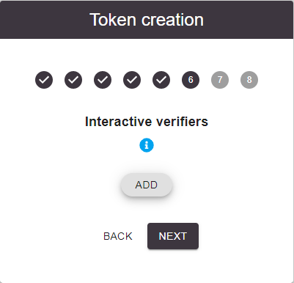

Using fin4xplorer, I couldn’t create a new token. It did not work to the next step.

I defined my token design as capped supply of 10000 units, transferable, burnable.

1. Decrypting Distributed Ledgers: Taxonomy, Classification and Blockchain Community Evaluation: <https://arxiv.org/pdf/1811.03419.pdf>